Dr. ZAKIR HUSAIN COLLEGE, ILAYANGUDI

DEPARTMENT OF PHYSICS

PROJECT REPORT

ON

DATA ANALYTICS

ANALYZING THE PERFORMANCE & EFFICIENCY OF THE RADISSON HOTELS USING DATA VISUALIZATION TECHNIQUES

TEAM ID: NM2023TMID24584

NANTHINI N 0620122010 asalu6620122010

VARSHINI S 0620122022 asalu6620122022

UDHAYAPRIYA M 0620122021 asalu6620122021

VINOTHINI A 0620122024 asalu6620122024

Faculty incharge,

Mr. P. KALEEL AHAMED M.Sc., M.Phil.,

ASSISTANT PROFESSOR,

DEPARTMENT OF PHYSICS,

Dr. ZAKIR HUSAIN COLLEGE,

ILAYANGUDI.

OVERVIEW & PURPOSE

The hotel industry is a broad category of businesses that provide lodging services for travellers and tourists. This can include a wide range of establishments, from luxury resorts to budget-friendly motels, as well as extended stay hotels, boutique hotels, and more. Hotels can be found in nearly every corner of the world, and are often a major component of the tourism and travel industry in a given area.

Radisson owns multiple five-star hotels across India. They have been in the hospitality industry for the past 100 years. Due to strategic moves from other competitors and ineffective decision-making in management, Radisson is losing its market share and revenue in the luxury/business hotels category. As a strategic move, the managing director of Radisson wanted to incorporate Business and Data Intelligence in order to regain their market share and revenue. Our task is to create an analytics dashboard & story to provide them insights to make better business decisions.

PROPLEM DESIGNING AND DESIGN MAKING

EMPATHY MAP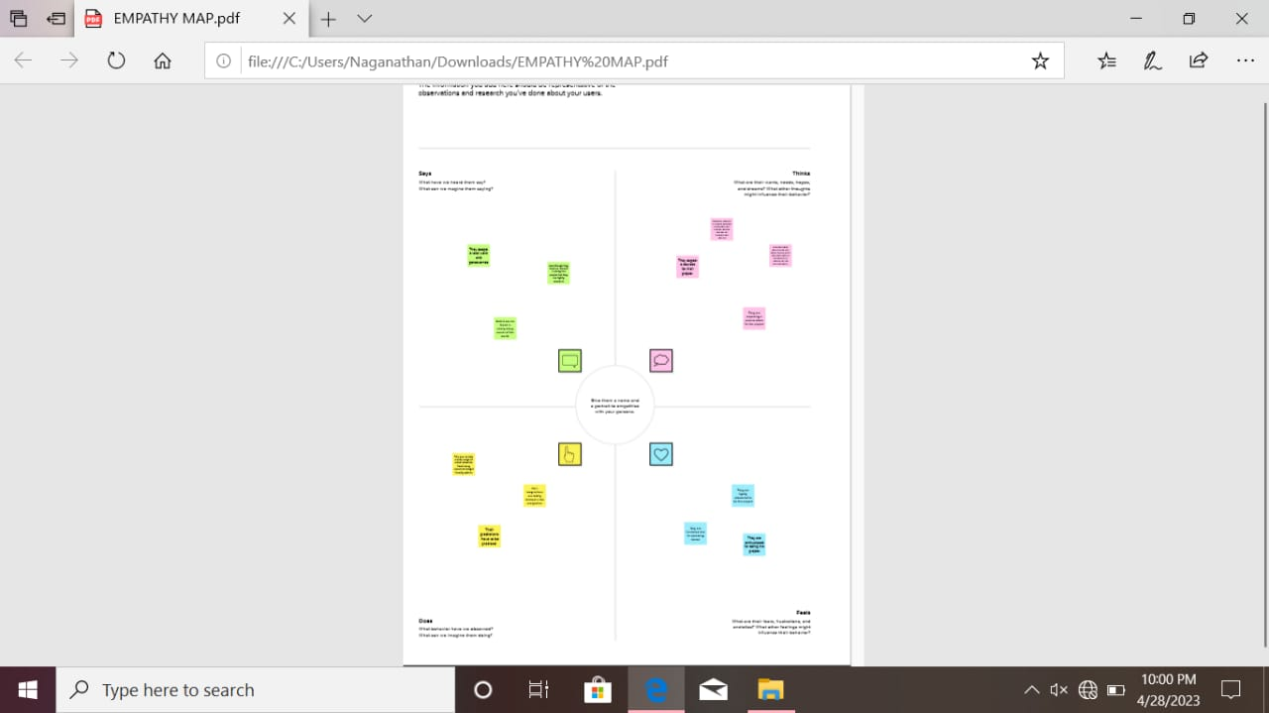

BRAINSTORMING AND IDEALISATION

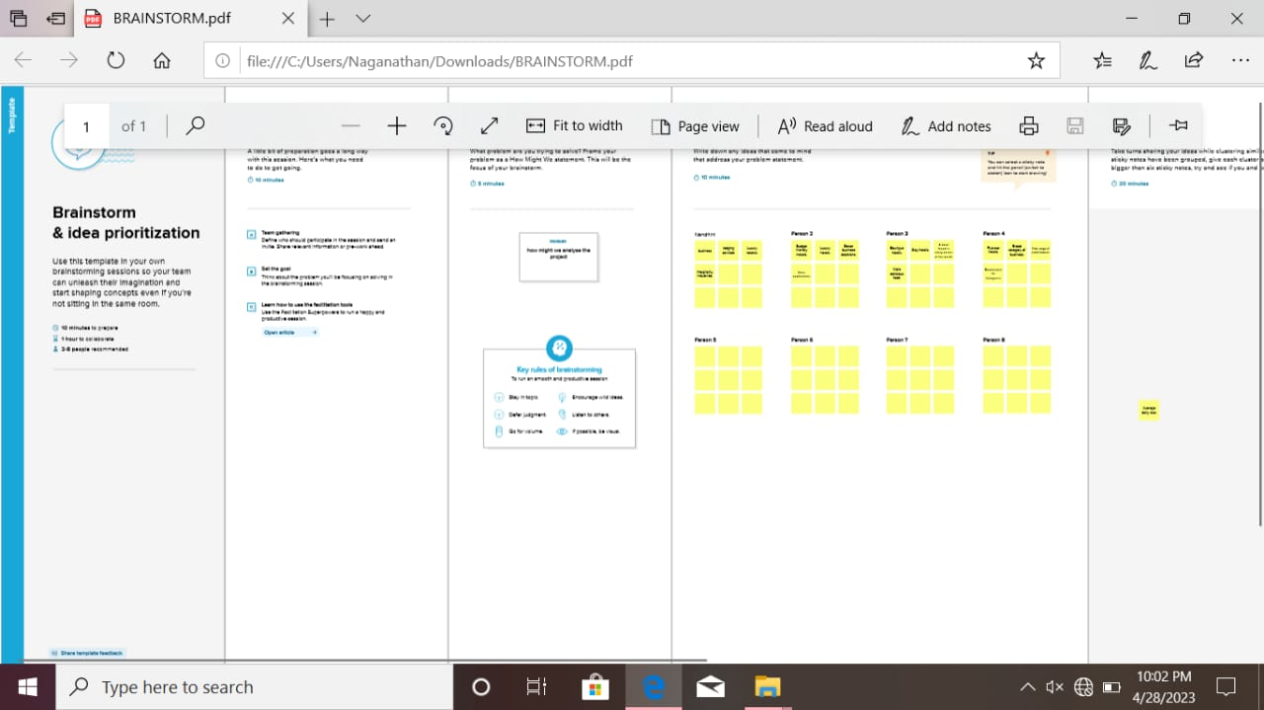

RESULT

DASHBOARD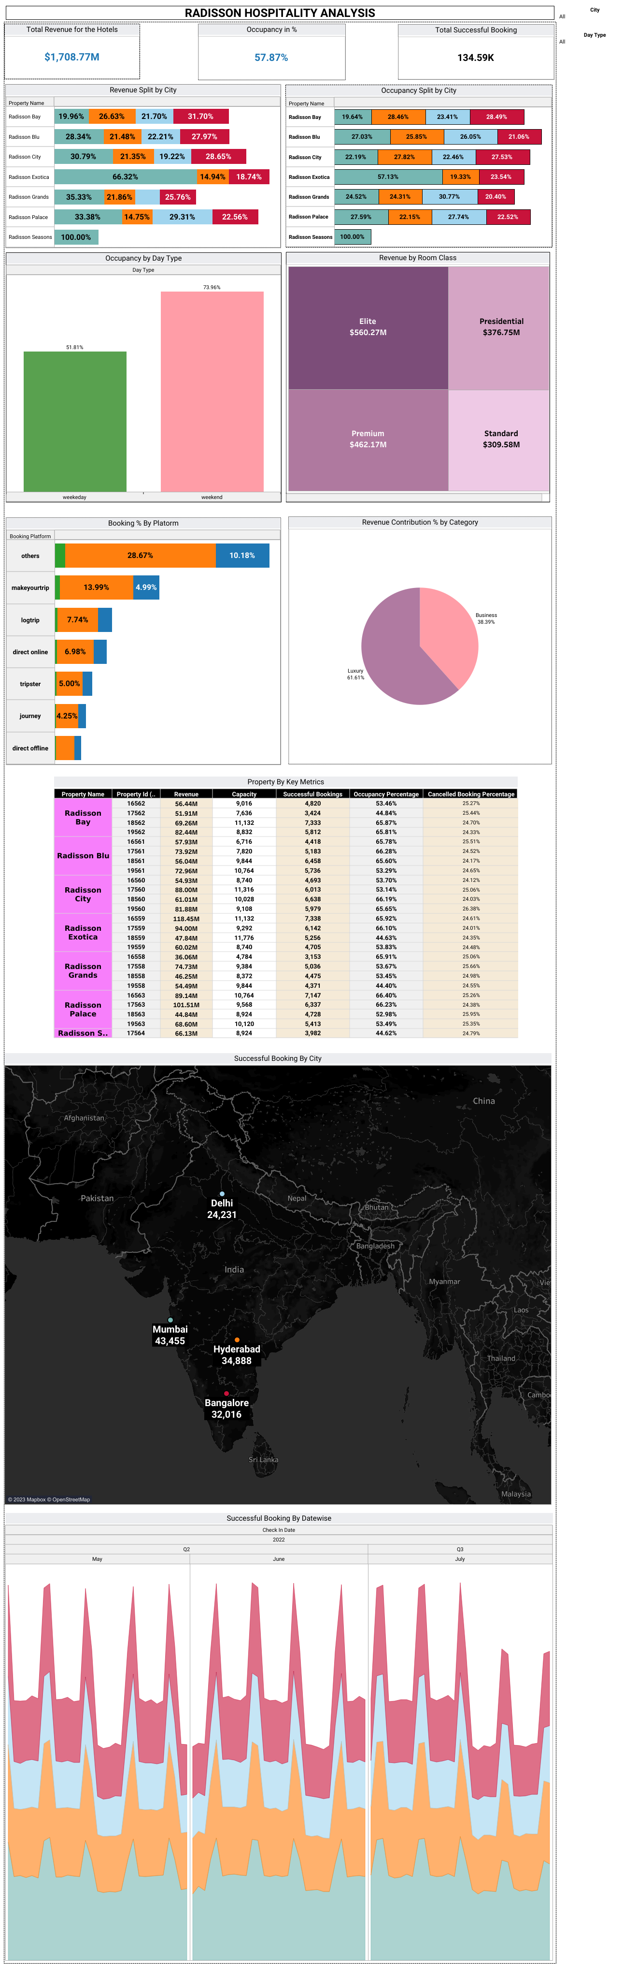

STORY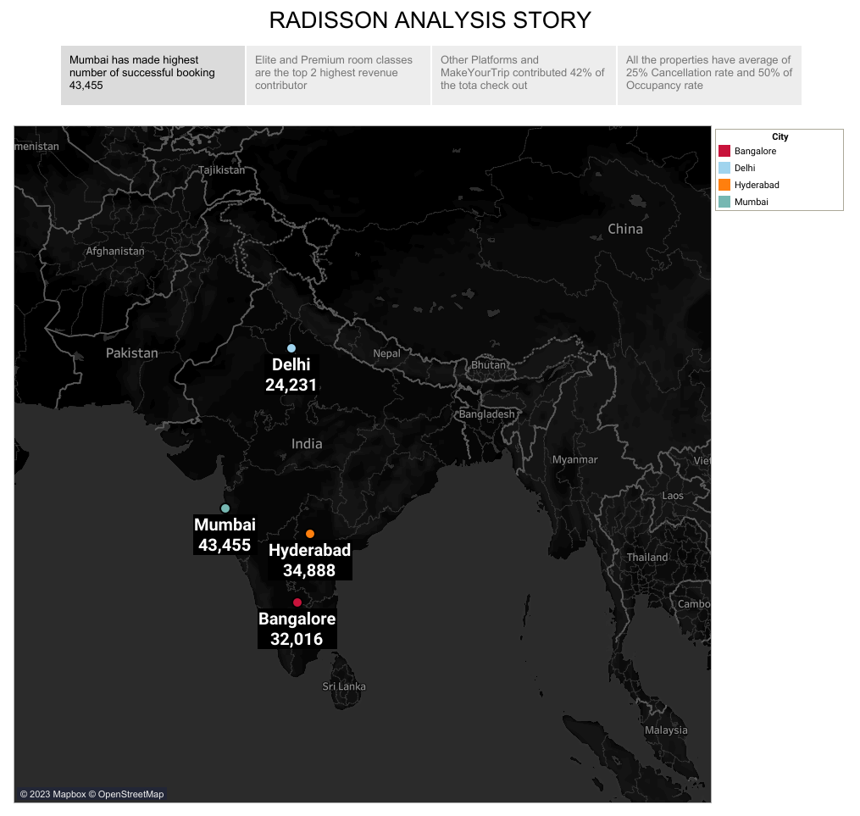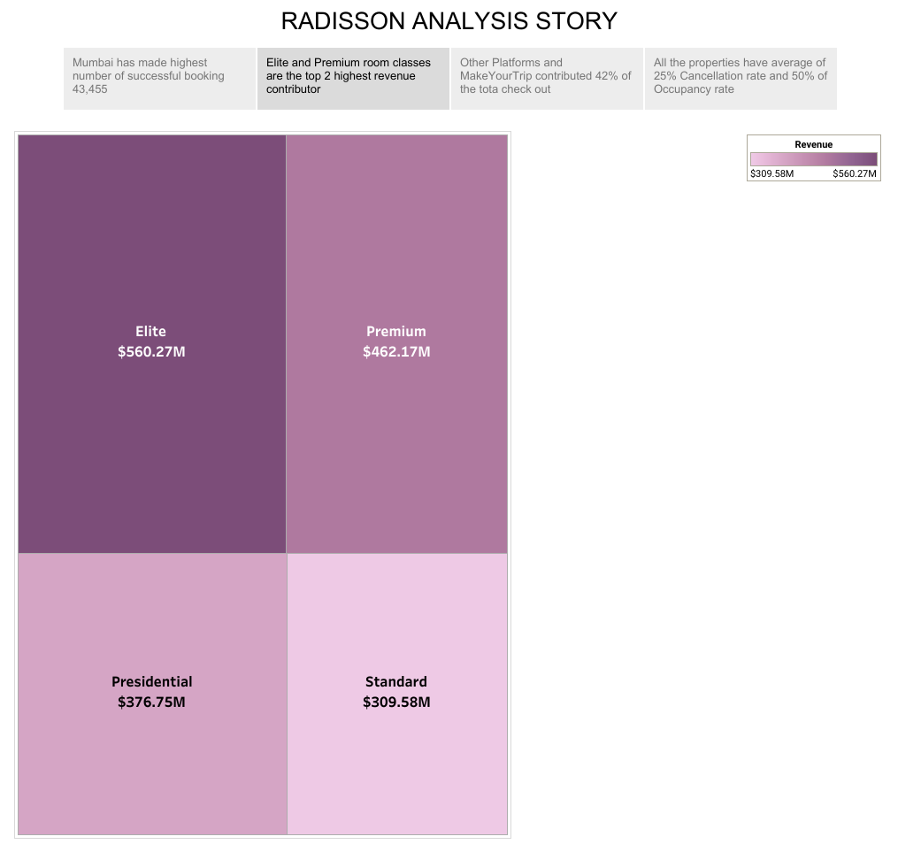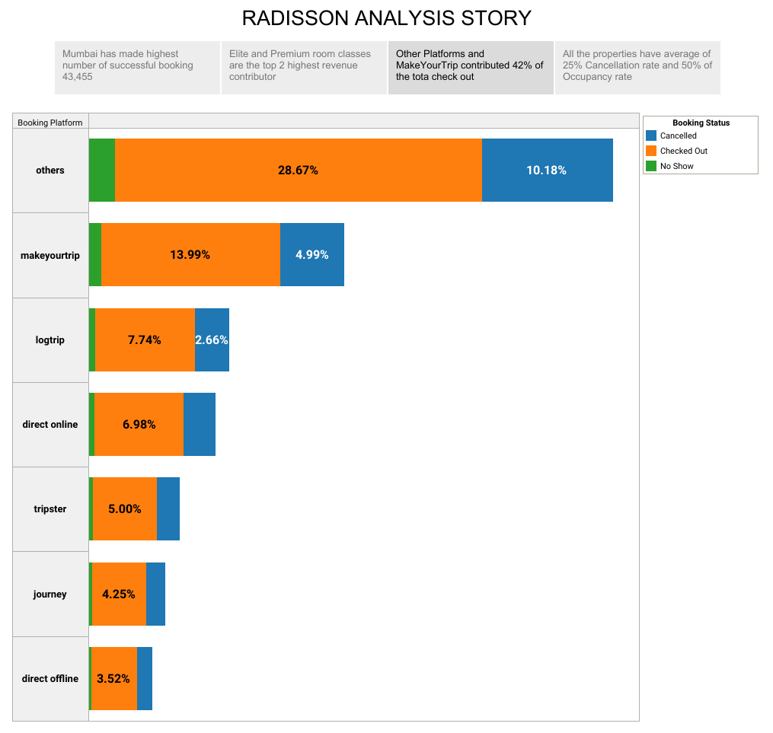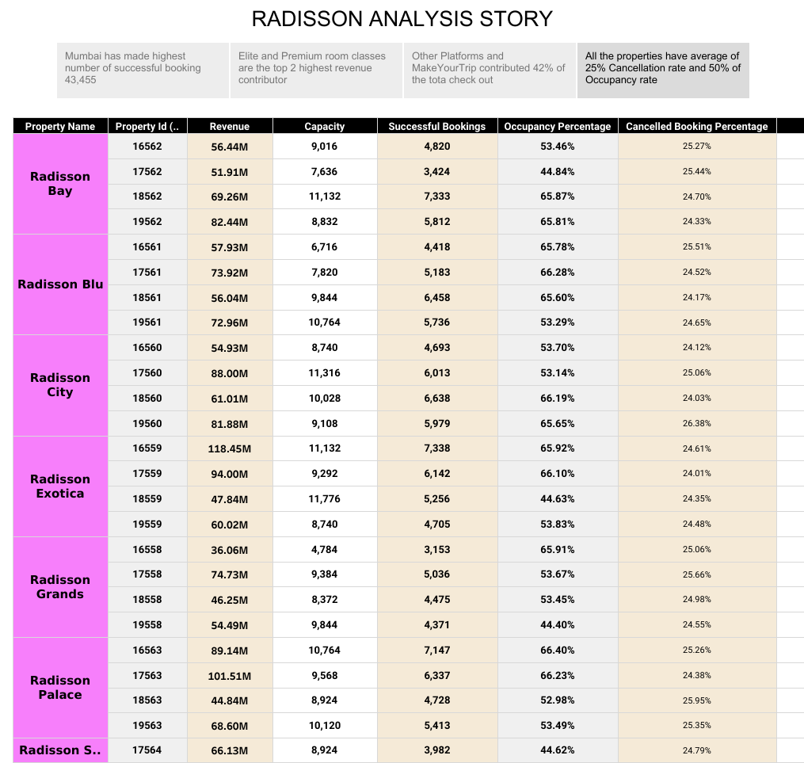

APPLICATION

ADVANTAGES

Data analytics have all sorts of applications in the lodging industry, chief among them is finding ways to increase revenue, save costs, streamline hotel operations, and improve guest satisfaction. Here are just a few examples of how hotels can use data to improve performance:

* Understand changes to traveler preferences to serve your customer base better
* Examine previous booking patterns to help increase future occupancy rates
* Compare pricing with competitors to develop an effective pricing strategy
* Analyze guest spending behavior to identify your most profitable segments
* Track labor costs per occupied room to identify optimal staffing levels that deliver increased guest satisfaction

DISADVANTAGES

Aside from accounting, revenue management may be the most data-heavy department in hotels. Revenue managers combine external data like market demand and competitor activity with internal data like historical performance and business on the books to [guide pricing decisions](https://www.cloudbeds.com/articles/hotel-dynamic-pricing/), inventory controls, promotions, and demand forecasting.

FUTURE SCOPE

With so many data sources to manage in the travel industry, hoteliers need a [modern PMS system](https://www.cloudbeds.com/property-management-system/) that provides seamless, secure connections to tools and applications in every department, centralizing and streamlining the collection, integration, storage, and usage of all types of data. With the right tools, virtually anyone can be a numbers person.

CONCLUSION

Hotel restaurants, bars, and room services tend to run on tight margins, so it’s important to [keep a tight rein on expenditures](https://www.cloudbeds.com/articles/how-hotel-operating-costs-affect-the-bottom-line/). If costs climb without commensurate increases in revenue, it can weigh heavily on the hotel’s balance sheet. Managers can analyze revenue data to find ways to increase guest spend through menu engineering, upselling, and promotions. It’s also important to analyze spending behavior to target guests with a high propensity to purchase F&B on property.

APPENDIX

SOURCE CODE

<!DOCTYPE html>

<html lang="en">

<head>

  <meta charset="utf-8">

  <meta content="width=device-width, initial-scale=1.0" name="viewport">

  <title>Radisson Hotel</title>

  <meta content="" name="description">

  <meta content="" name="keywords">

  <!-- Favicons -->

  <link rel="stylesheet" href="{{url_for('static',filename='img/favicon.png')}}" rel="icon">

  <link rel="stylesheet" href="{{url_for('static',filename='img/apple-touch-icon.png')}}" rel="apple-touch-icon">

  <link rel="stylesheet" href="{{url_for('static',filename='vendor/animate.css/animate.min.css')}}">

  <!-- Google Fonts -->

  <link href="https://fonts.googleapis.com/css?family=Open+Sans:300,300i,400,400i,600,600i,700,700i|Playfair+Display:ital,wght@0,400;0,500;0,600;0,700;1,400;1,500;1,600;1,700|Poppins:300,300i,400,400i,500,500i,600,600i,700,700i" rel="stylesheet">

  <!-- Vendor CSS Files -->

  <link rel="stylesheet" href="{{url_for('static',filename='vendor/animate.css/animate.min.css')}}">

  <link rel="stylesheet" href="{{url_for('static',filename='vendor/aos/aos.css')}}">

  <link rel="stylesheet" href="{{url_for('static',filename='vendor/bootstrap/css/bootstrap.min.css')}}">

  <link rel="stylesheet" href="{{url_for('static',filename='vendor/bootstrap-icons/bootstrap-icons.css')}}">

  <link rel="stylesheet" href="{{url_for('static',filename='vendor/boxicons/css/boxicons.min.css')}}">

  <link rel="stylesheet" href="{{url_for('static',filename='vendor/glightbox/css/glightbox.min.css')}}">

  <link rel="stylesheet" href="{{url_for('static',filename='vendor/swiper/swiper-bundle.min.css')}}">

  <!-- Template Main CSS File -->

  <link rel="stylesheet" href="{{url_for('static',filename='css/style.css')}}">

  <!-- =======================================================

  * Template Name: Restaurantly - v3.9.1

  * Template URL: https://bootstrapmade.com/restaurantly-restaurant-template/

  * Author: BootstrapMade.com

  * License: https://bootstrapmade.com/license/

  ======================================================== -->

</head>

<body>

  <!-- ======= Top Bar ======= -->

  <div id="topbar" class="d-flex align-items-center fixed-top">

    <div class="container d-flex justify-content-center justify-content-md-between">

      <div class="contact-info d-flex align-items-center">

        <i class="bi bi-phone d-flex align-items-center"><span>+91 9589 55488 55</span></i>

        <i class="bi bi-clock d-flex align-items-center ms-4"><span> Mon-Sat: 10:00AM - 11:00PM</span></i>

      </div>

    </div>

  </div>

  <!-- ======= Header ======= -->

  <header id="header" class="fixed-top d-flex align-items-cente">

    <div class="container-fluid container-xl d-flex align-items-center justify-content-lg-between">

      <h1 class="logo me-auto me-lg-0"><a href="{{ url_for('index') }}">Radisson Hotel</a></h1>

      <!-- Uncomment below if you prefer to use an image logo -->

      <!-- <a href="index.html" class="logo me-auto me-lg-0"><img src="assets/img/logo.png" alt="" class="img-fluid"></a>-->

      <nav id="navbar" class="navbar order-last order-lg-0">

        <ul>

          <li><a class="nav-link scrollto active" href="#hero">Home</a></li>

          <li><a class="nav-link scrollto" href="#about">About</a></li>

          <li><a class="nav-link scrollto" href="#events">Events</a></li>

          <li><a class="nav-link scrollto" href="#chefs">Dashboard & Story</a></li>

          <li><a class="nav-link scrollto" href="#gallery">Gallery</a></li>

          <li><a class="nav-link scrollto" href="#contact">Contact</a></li>

        </ul>

        <i class="bi bi-list mobile-nav-toggle"></i>

      </nav><!-- .navbar -->

    </div>

  </header><!-- End Header -->

  <!-- ======= Hero Section ======= -->

  <section id="hero" class="d-flex align-items-center">

    <div class="container position-relative text-center text-lg-start" data-aos="zoom-in" data-aos-delay="100">

      <div class="row">

        <div class="col-lg-8">

          <h1>Welcome to <span>Radisson Hotel</span></h1>

          <h2>Radisson Hotels is an international hotel chain headquartered in the United States. A division of the Radisson Hotel Group, it operates the brands Radisson Blu, Radisson RED, Radisson Collection, Country Inn & Suites, and Park Inn by Radisson, among others.</h2>

        </div>

        <div class="col-lg-4 d-flex align-items-center justify-content-center position-relative" data-aos="zoom-in" data-aos-delay="200">

          <a href="https://www.youtube.com/watch?v=u6BOC7CDUTQ" class="glightbox play-btn"></a>

        </div>

      </div>

    </div>

  </section><!-- End Hero -->

  <main id="main">

    <!-- ======= About Section ======= -->

    <section id="about" class="about">

      <div class="container" data-aos="fade-up">

        <div class="row">

          <div class="col-lg-6 order-1 order-lg-2" data-aos="zoom-in" data-aos-delay="100">

            <div class="about-img">

               <img src="static/img/about.jpg" alt="">

            </div>

          </div>

          <div class="col-lg-6 pt-4 pt-lg-0 order-2 order-lg-1 content">

            <h3>Radisson Hotel Analysis</h3>

            <p class="fst-italic">

              Radisson owns multiple five-star hotels across India. They have been in the hospitality industry for the past 100 years. Due to strategic moves from other competitors and ineffective decision-making in management, Radisson are losing its market share and revenue in the luxury/business hotels category. As a strategic move, the managing director of Radisson wanted to incorporate Business and Data Intelligence in order to regain their market share and revenue.

            <p>

            </p>

          </div>

        </div>

      </div>

    </section><!-- End About Section -->

    <!-- ======= Events Section ======= -->

    <section id="events" class="events">

      <div class="container" data-aos="fade-up">

        <div class="section-title">

          <h2>Events</h2>

          <p>Organize Your Events in our Radisson Hotel</p>

        </div>

        <div class="events-slider swiper" data-aos="fade-up" data-aos-delay="100">

          <div class="swiper-wrapper">

            <div class="swiper-slide">

              <div class="row event-item">

                <div class="col-lg-6">

                  <img src="static/img/event-birthday.jpg" class="img-fluid" alt="">

                </div>

                <div class="col-lg-6 pt-4 pt-lg-0 content">

                  <h3>Birthday Parties</h3>

                  <div class="price">

                    <p><span>$189</span></p>

                  </div>

                  <p class="fst-italic">

                  </p>

                </div>

              </div>

            </div><!-- End testimonial item -->

            <div class="swiper-slide">

              <div class="row event-item">

                <div class="col-lg-6">

                  <img src="static/img/event-private.jpg" class="img-fluid" alt="">

                </div>

                <div class="col-lg-6 pt-4 pt-lg-0 content">

                  <h3>Private Parties</h3>

                  <div class="price">

                    <p><span>$290</span></p>

                  </div>

                  <p class="fst-italic">

                  </p>

                </div>

              </div>

            </div><!-- End testimonial item -->

            <div class="swiper-slide">

              <div class="row event-item">

                <div class="col-lg-6">

                  <img src="static/img/event-custom.jpg" class="img-fluid" alt="">

                </div>

                <div class="col-lg-6 pt-4 pt-lg-0 content">

                  <h3>Custom Parties</h3>

                  <div class="price">

                    <p><span>$99</span></p>

                  </div>

                </div>

              </div>

            </div><!-- End testimonial item -->

          </div>

          <div class="swiper-pagination"></div>

        </div>

      </div>

    </section><!-- End Events Section -->

    <!-- ======= Gallery Section ======= -->

    <section id="gallery" class="gallery">

      <div class="container" data-aos="fade-up">

        <div class="section-title">

          <h2>Gallery</h2>

          <p>Some photos from Our Restaurant</p>

        </div>

      </div>

      <div class="container-fluid" data-aos="fade-up" data-aos-delay="100">

        <div class="row g-0">

          <div class="col-lg-3 col-md-4">

            <div class="gallery-item">

              <a href="static/img/gallery/gallery-1.jpg" class="gallery-lightbox" data-gall="gallery-item">

                <img src="static/img/gallery/gallery-1.jpg" alt="" class="img-fluid">

              </a>

            </div>

          </div>

          <div class="col-lg-3 col-md-4">

            <div class="gallery-item">

              <a href="static/img/gallery/gallery-2.jpg" class="gallery-lightbox" data-gall="gallery-item">

                <img src="static/img/gallery/gallery-2.jpg" alt="" class="img-fluid">

              </a>

            </div>

          </div>

          <div class="col-lg-3 col-md-4">

            <div class="gallery-item">

              <a href="static/img/gallery/gallery-3.jpg" class="gallery-lightbox" data-gall="gallery-item">

                <img src="static/img/gallery/gallery-3.jpg" alt="" class="img-fluid">

              </a>

            </div>

          </div>

          <div class="col-lg-3 col-md-4">

            <div class="gallery-item">

              <a href="static/img/gallery/gallery-4.jpg" class="gallery-lightbox" data-gall="gallery-item">

                <img src="static/img/gallery/gallery-4.jpg" alt="" class="img-fluid">

              </a>

            </div>

          </div>

          <div class="col-lg-3 col-md-4">

            <div class="gallery-item">

              <a href="static/img/gallery/gallery-5.jpg" class="gallery-lightbox" data-gall="gallery-item">

                <img src="static/img/gallery/gallery-5.jpg" alt="" class="img-fluid">

              </a>

            </div>

          </div>

          <div class="col-lg-3 col-md-4">

            <div class="gallery-item">

              <a href="static/img/gallery/gallery-6.jpg" class="gallery-lightbox" data-gall="gallery-item">

                <img src="static/img/gallery/gallery-6.jpg" alt="" class="img-fluid">

              </a>

            </div>

          </div>

          <div class="col-lg-3 col-md-4">

            <div class="gallery-item">

              <a href="static/img/gallery/gallery-7.jpg" class="gallery-lightbox" data-gall="gallery-item">

                <img src="static/img/gallery/gallery-7.jpg" alt="" class="img-fluid">

              </a>

            </div>

          </div>

          <div class="col-lg-3 col-md-4">

            <div class="gallery-item">

              <a href="static/img/gallery/gallery-8.jpg" class="gallery-lightbox" data-gall="gallery-item">

                <img src="static/img/gallery/gallery-8.jpg" alt="" class="img-fluid">

              </a>

            </div>

          </div>

        </div>

      </div>

    </section><!-- End Gallery Section -->

    <!-- ======= Chefs Section ======= -->

    <section id="chefs" class="chefs">

      <div class="container" data-aos="fade-up">

        <div class="section-title">

          <center><p>Analysis Dashboard</p></center>

          <div class='tableauPlaceholder' id='viz1682655988863' style='position: relative'><noscript><a href='#'><img alt='RADISSON HOSPITALITY ANALYSIS ' src='https:&#47;&#47;public.tableau.com&#47;static&#47;images&#47;Ra&#47;RadissonHospitalityAnalysisDashboard_16826589682070&#47;RADISSONHOSPITALITYANALYSIS&#47;1_rss.png' style='border: none' /></a></noscript><object class='tableauViz'  style='display:none;'><param name='host_url' value='https%3A%2F%2Fpublic.tableau.com%2F' /> <param name='embed_code_version' value='3' /> <param name='site_root' value='' /><param name='name' value='RadissonHospitalityAnalysisDashboard_16826589682070&#47;RADISSONHOSPITALITYANALYSIS' /><param name='tabs' value='no' /><param name='toolbar' value='yes' /><param name='static_image' value='https:&#47;&#47;public.tableau.com&#47;static&#47;images&#47;Ra&#47;RadissonHospitalityAnalysisDashboard_16826589682070&#47;RADISSONHOSPITALITYANALYSIS&#47;1.png' /> <param name='animate_transition' value='yes' /><param name='display_static_image' value='yes' /><param name='display_spinner' value='yes' /><param name='display_overlay' value='yes' /><param name='display_count' value='yes' /><param name='language' value='en-US' /><param name='filter' value='publish=yes' /></object></div>                <script type='text/javascript'>                    var divElement = document.getElementById('viz1682655988863');                    var vizElement = divElement.getElementsByTagName('object')[0];                    if ( divElement.offsetWidth > 800 ) { vizElement.style.width='1320px';vizElement.style.height='4096px';} else if ( divElement.offsetWidth > 500 ) { vizElement.style.width='1320px';vizElement.style.height='4096px';} else { vizElement.style.width='100%';vizElement.style.height='3177px';}                     var scriptElement = document.createElement('script');                    scriptElement.src = 'https://public.tableau.com/javascripts/api/viz_v1.js';                    vizElement.parentNode.insertBefore(scriptElement, vizElement);                </script>

          <center><p>Analysis Story</p></center>

        </div>

        <div class="row">

          <div class='tableauPlaceholder' id='viz1682655910679' style='position: relative'><noscript><a href='#'><img alt='RADISSON ANALYSIS STORY ' src='https:&#47;&#47;public.tableau.com&#47;static&#47;images&#47;Ra&#47;RadissonHospitalityAnalysisStory&#47;RadissonAnalysisStory&#47;1_rss.png' style='border: none' /></a></noscript><object class='tableauViz'  style='display:none;'><param name='host_url' value='https%3A%2F%2Fpublic.tableau.com%2F' /> <param name='embed_code_version' value='3' /> <param name='site_root' value='' /><param name='name' value='RadissonHospitalityAnalysisStory&#47;RadissonAnalysisStory' /><param name='tabs' value='no' /><param name='toolbar' value='yes' /><param name='static_image' value='https:&#47;&#47;public.tableau.com&#47;static&#47;images&#47;Ra&#47;RadissonHospitalityAnalysisStory&#47;RadissonAnalysisStory&#47;1.png' /> <param name='animate_transition' value='yes' /><param name='display_static_image' value='yes' /><param name='display_spinner' value='yes' /><param name='display_overlay' value='yes' /><param name='display_count' value='yes' /><param name='language' value='en-US' /><param name='filter' value='publish=yes' /></object></div>                <script type='text/javascript'>                    var divElement = document.getElementById('viz1682655910679');                    var vizElement = divElement.getElementsByTagName('object')[0];                    vizElement.style.width='1016px';vizElement.style.height='991px';                    var scriptElement = document.createElement('script');                    scriptElement.src = 'https://public.tableau.com/javascripts/api/viz_v1.js';                    vizElement.parentNode.insertBefore(scriptElement, vizElement);                </script>

        </div>

      </div>

    </section><!-- End Chefs Section -->

    <!-- ======= Contact Section ======= -->

    <section id="contact" class="contact">

      <div class="container" data-aos="fade-up">

        <div class="section-title">

          <h2>Contact</h2>

          <p>Contact Us</p>

        </div>

      </div>

      <div class="container" data-aos="fade-up">

        <div class="row mt-5">

          <div class="col-lg-4">

            <div class="info">

              <div class="address">

                <i class="bi bi-geo-alt"></i>

                <h4>Location:</h4>

                <p>Radisson Hotel Bhopal,Gulmohar Colony, Bhopal, Madhya Pradesh 462039</p>

              </div>

              <div class="open-hours">

                <i class="bi bi-clock"></i>

                <h4>Open Hours:</h4>

                <p>

                  Monday-Saturday:<br>

                  10:00 AM - 11:00 PM

                </p>

              </div>

              <div class="email">

                <i class="bi bi-envelope"></i>

                <h4>Email:</h4>

                <p>info@radisson.com</p>

              </div>

              <div class="phone">

                <i class="bi bi-phone"></i>

                <h4>Call:</h4>

                <p>+91 9589 55488 55</p>

              </div>

            </div>

          </div>

          <div class="col-lg-8 mt-5 mt-lg-0">

            <div class="mapouter"><div class="gmap_canvas"><iframe class="gmap_iframe" frameborder="0" scrolling="no" marginheight="0" marginwidth="0" src="https://maps.google.com/maps?width=600&amp;height=400&amp;hl=en&amp;q=radisson bhopal&amp;t=&amp;z=14&amp;ie=UTF8&amp;iwloc=B&amp;output=embed"></iframe><a href="https://mcpedls.com/">minecraft download</a></div><style>.mapouter{position:relative;text-align:right;width:600px;height:400px;}.gmap_canvas {overflow:hidden;background:none!important;width:600px;height:400px;}.gmap_iframe {width:600px!important;height:400px!important;}</style></div>

          </div>

        </div>

      </div>

    </section><!-- End Contact Section -->

  </main><!-- End #main -->

  <!-- ======= Footer ======= -->

  <footer id="footer">

    <div class="footer-top">

      <div class="container">

        <div class="row">

          <div class="col-lg-3 col-md-6">

            <div class="footer-info">

              <h3>Radisson Hotel</h3>

              <p>

                Radisson Hotel Bhopal,Gulmohar Colony <br>

                Bhopal, Madhya Pradesh 462039<br><br>

                <strong>Phone:</strong> +91 9589 55488 55<br>

                <strong>Email:</strong> info@radisson.com<br>

              </p>

              <div class="social-links mt-3">

                <a href="#" class="twitter"><i class="bx bxl-twitter"></i></a>

                <a href="#" class="facebook"><i class="bx bxl-facebook"></i></a>

                <a href="#" class="instagram"><i class="bx bxl-instagram"></i></a>

                <a href="#" class="google-plus"><i class="bx bxl-skype"></i></a>

                <a href="#" class="linkedin"><i class="bx bxl-linkedin"></i></a>

              </div>

            </div>

          </div>

          <div class="col-lg-2 col-md-6 footer-links">

            <h4>Useful Links</h4>

            <ul>

              <li><i class="bx bx-chevron-right"></i> <a href="#">Home</a></li>

              <li><i class="bx bx-chevron-right"></i> <a href="#">About us</a></li>

              <li><i class="bx bx-chevron-right"></i> <a href="#">Services</a></li>

            </ul>

          </div>

          </div>

        </div>

      </div>

    </div>

    <div class="container">

      <div class="copyright">

        &copy; Copyright <strong><span>Radisson Hotel</span></strong>. All Rights Reserved

      </div>

      <div class="credits">

        <!-- All the links in the footer should remain intact. -->

        <!-- You can delete the links only if you purchased the pro version. -->

        <!-- Licensing information: https://bootstrapmade.com/license/ -->

        <!-- Purchase the pro version with working PHP/AJAX contact form: https://bootstrapmade.com/restaurantly-restaurant-template/ -->

        Designed by <a href="https://bootstrapmade.com/">SmartBridge</a>

      </div>

    </div>

  </footer><!-- End Footer -->

  <div id="preloader"></div>

  <a href="#" class="back-to-top d-flex align-items-center justify-content-center"><i class="bi bi-arrow-up-short"></i></a>

  <!-- Vendor JS Files -->

  <script src="{{ url_for('static', filename='vendor/aos/aos.js') }}"></script>

  <script src="{{ url_for('static', filename='vendor/bootstrap/js/bootstrap.bundle.min.js') }}"></script>

  <script src="{{ url_for('static', filename='vendor/glightbox/js/glightbox.min.js') }}"></script>

  <script src="{{ url_for('static', filename='vendor/isotope-layout/isotope.pkgd.min.js') }}"></script>

  <script src="{{ url_for('static', filename='vendor/swiper/swiper-bundle.min.js') }}"></script>

  <script src="{{ url_for('static', filename='vendor/php-email-form/validate.js') }}"></script>

  <!-- Template Main JS File -->

  <script src="{{ url_for('static', filename='js/main.js') }}"></script>

</body>

</html><div class='tableauPlaceholder' id='viz1682655988863' style='position: relative'><noscript><a href='#'><img alt='RADISSON HOSPITALITY ANALYSIS ' src='https:&#47;&#47;public.tableau.com&#47;static&#47;images&#47;Ra&#47;RadissonHospitalityAnalysisDashboard_16826589682070&#47;RADISSONHOSPITALITYANALYSIS&#47;1_rss.png' style='border: none' /></a></noscript><object class='tableauViz'  style='display:none;'><param name='host_url' value='https%3A%2F%2Fpublic.tableau.com%2F' /> <param name='embed_code_version' value='3' /> <param name='site_root' value='' /><param name='name' value='RadissonHospitalityAnalysisDashboard_16826589682070&#47;RADISSONHOSPITALITYANALYSIS' /><param name='tabs' value='no' /><param name='toolbar' value='yes' /><param name='static_image' value='https:&#47;&#47;public.tableau.com&#47;static&#47;images&#47;Ra&#47;RadissonHospitalityAnalysisDashboard_16826589682070&#47;RADISSONHOSPITALITYANALYSIS&#47;1.png' /> <param name='animate_transition' value='yes' /><param name='display_static_image' value='yes' /><param name='display_spinner' value='yes' /><param name='display_overlay' value='yes' /><param name='display_count' value='yes' /><param name='language' value='en-US' /><param name='filter' value='publish=yes' /></object></div>                <script type='text/javascript'>                    var divElement = document.getElementById('viz1682655988863');                    var vizElement = divElement.getElementsByTagName('object')[0];                    if ( divElement.offsetWidth > 800 ) { vizElement.style.width='1320px';vizElement.style.height='4096px';} else if ( divElement.offsetWidth > 500 ) { vizElement.style.width='1320px';vizElement.style.height='4096px';} else { vizElement.style.width='100%';vizElement.style.height='3177px';}                     var scriptElement = document.createElement('script');                    scriptElement.src = 'https://public.tableau.com/javascripts/api/viz_v1.js';                    vizElement.parentNode.insertBefore(scriptElement, vizElement);                </script>

<div class='tableauPlaceholder' id='viz1682655910679' style='position: relative'><noscript><a href='#'><img alt='RADISSON ANALYSIS STORY ' src='https:&#47;&#47;public.tableau.com&#47;static&#47;images&#47;Ra&#47;RadissonHospitalityAnalysisStory&#47;RadissonAnalysisStory&#47;1_rss.png' style='border: none' /></a></noscript><object class='tableauViz'  style='display:none;'><param name='host_url' value='https%3A%2F%2Fpublic.tableau.com%2F' /> <param name='embed_code_version' value='3' /> <param name='site_root' value='' /><param name='name' value='RadissonHospitalityAnalysisStory&#47;RadissonAnalysisStory' /><param name='tabs' value='no' /><param name='toolbar' value='yes' /><param name='static_image' value='https:&#47;&#47;public.tableau.com&#47;static&#47;images&#47;Ra&#47;RadissonHospitalityAnalysisStory&#47;RadissonAnalysisStory&#47;1.png' /> <param name='animate_transition' value='yes' /><param name='display_static_image' value='yes' /><param name='display_spinner' value='yes' /><param name='display_overlay' value='yes' /><param name='display_count' value='yes' /><param name='language' value='en-US' /><param name='filter' value='publish=yes' /></object></div>                <script type='text/javascript'>                    var divElement = document.getElementById('viz1682655910679');                    var vizElement = divElement.getElementsByTagName('object')[0];                    vizElement.style.width='1016px';vizElement.style.height='991px';                    var scriptElement = document.createElement('script');                    scriptElement.src = 'https://public.tableau.com/javascripts/api/viz_v1.js';                    vizElement.parentNode.insertBefore(scriptElement, vizElement);                </script>